


DEPI Graduation Project Final Report

HEALTHCARE PREDICTIVE ANALYTICS PROJECT
Stroke Risk Prediction System

Group Code: CAI_AIS4_S2

Instructor: Ahmed Mostafa

Team Members | Email Address
Muuhmd Salah Abd El-Bari (TL) | muhamdsalah7124@gmail.com
Nermine Samir Abd El-Aty | nerminesamir5@gmail.com
Toqa Hamed Mohamed | toqahamed18@gmail.com
Goerge Emil Sadeq | george443522@feng.bu.edu.eg
Omar Ahmed Mostafa | mromar84005@gmail.com
Mostafa Mohamed Foaad | mostafashams000444@gmail.com

Table of Contents
Project Proposal 3
Project overview 3
Problem Statement 3
Objectives 3
Scope 3
Project Milestones 4
Task Assignments & Roles 4
Dataset Exploration (EDA) 4
Introduction 4
Dataset Overview 5
Data Quality Checks 5
Numeric Feature Summary 6
Target Class Distribution 7
Numeric Feature Distributions & Outliers 7
Categorical Feature Distributions 8
Bivariate Analysis vs. Stroke 9
Correlation Analysis 11
Missing Value Handling 12
Key EDA Findings 12
Machine Learning Pipeline 12
Preprocessing Pipeline 12
Train / Validation / Test Split 13
Model Comparison (6 Candidates) 13
Best Model Selection & Threshold Tuning 14
Evaluation Curves & Final Metrics 14
Healthcare Context 15
MLOps, API & Deployment 15
REST API (FastAPI) 15
Streamlit Web Application 15
Monitoring & Retraining Strategy 16
Testing & Quality Assurance 16
Test Plan & Functional Test Cases 16
Input Validation Tests 17
Application Walkthrough 18
Step 1 — Empty Form 18
Step 2 — High-Risk Patient 18
Step 3 — Low-Risk Pateint 19
Model Summary & Current Performance 19
Limitations & Future Work 20
Conclusion & Appendix - Repository Structure 21

Project Proposal

Project overview
The Healthcare Predictive Analytics project focuses on developing a predictive model to improve healthcare outcomes by providing data-driven insights. The model will be designed to help healthcare professionals with tasks such as patient risk prediction, trend identification in health metrics, and making informed decisions based on predictive analytics. The project will utilize machine learning models to forecast healthcare-related outcomes, focusing on improving patient care and resource management.

Problem Statement
Stroke is a major cause of death and long-term disability. The practical problem is not only to build a classifier, but to build an end-to-end healthcare analytics workflow that can ingest patient records, identify risk patterns, train a reproducible model, and expose the trained model through a simple interface for real-time prediction.
This project builds a predictive system that estimates a patient's risk of stroke using demographic factors (age, gender, marital status), clinical indicators (hypertension, heart disease, average glucose level, BMI), and lifestyle factors (work type, residence type, smoking status). The goal is to support early screening and triage rather than replace clinical diagnosis.

Objectives
- Stroke Risk Prediction: Build and compare machine learning classifiers (Logistic Regression, Random Forest, and Histogram-based Gradient Boosting) that estimate the probability of stroke from routinely collected patient data.
- Imbalance-Aware Evaluation: Because only ~4.9% of records are positive for stroke, prioritize Recall, F1-score, ROC-AUC, and PR-AUC over raw accuracy, which is misleading on imbalanced clinical data.
- Leak-Free Preprocessing: Encapsulate all preprocessing (imputation, scaling, one-hot encoding) inside a single scikit-learn Pipeline fitted only on the training split, so no information from the test set leaks into training.
- Threshold Optimization: Move beyond the default 0.5 decision threshold and tune it to balance false negatives (missed strokes) against false positives (unnecessary alerts).
- Deployable Artifact: Persist the final pipeline (preprocessing + model) as a single serialized object that can be loaded by a lightweight web application in the deployment milestone.

Project Scope
- Data Source: The public Kaggle “Stroke Prediction Dataset” (healthcare-dataset-stroke-data.csv) — 5,110 patient records, 12 columns.
- Exploratory Data Analysis: Distribution analysis, class-balance checks, bivariate analysis against the target, correlation analysis, and missing-value diagnostics.
- Preprocessing: Median imputation with a missing-value indicator.
- Deployment scope: Local Streamlit application and FastAPI endpoints for real-time and batch predictions.
- Modeling: Stratified train/test split, 5-fold stratified cross-validation, and comparison of three classifiers using class-imbalance-aware metrics.
- Clinical scope: Educational decision-support prototype; outputs are not medical advice and require stakeholder validation before production use.

Project Milestones
Milestone | Assignment expectation | Project evidence
1 | Data Collection, Exploration, and Preprocessing | EDA notebook, raw dataset, processed model-ready CSV
2 | Data Analysis and Visualization | EDA figures, correlation heatmap, stroke-rate analysis
3 | Predictive Model Development and Optimization | Six-model comparison, tuned threshold, final model artifact
4 | MLOps, Deployment, and Monitoring | Streamlit app, FastAPI API, health and predict endpoints
5 | Final Documentation and Presentation | This Word report with figures, results and test evidence

Task Assignments & Roles

Team Member | Responsibilities
Muuhmd Salah (TL) | Data collection, preprocessing, and feature engineering
Nermine Samir | Exploratory data analysis and visualization
Toqa Hamed | Model Training and development
Goerge Emil | Model optimization and deployment
Omar Ahmed | API development, web dashboard, and integration
Mostafa Mohamed | Coordination, documentation, and final reporting

Dataset Exploration (EDA)

Introduction
The dataset combines demographic, clinical, and lifestyle features for 5,110 patients and is drawn from the public Kaggle “Stroke Prediction Dataset.” The goal of this analysis (Milestones 1 and 2) is to understand feature distributions, identify data-quality issues, and surface the relationships, most likely to help a classifier separate stroke from non-stroke cases.
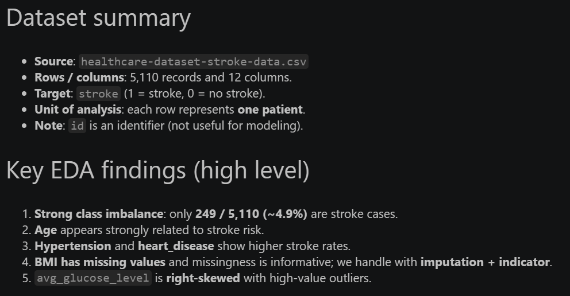

Dataset Overview
The dataset is strongly imbalanced: the positive stroke class represents fewer than 5% of records. This makes ordinary accuracy a weak success metric, because a majority-class model can appear accurate while missing the clinically important minority class.
- Demographic features: gender, age, ever_married, Residence_type
- Clinical indicators: hypertension, heart_disease, avg_glucose_level, bmi
- Lifestyle factors: work_type, smoking_status
- Target variable: stroke (1 = patient had a stroke, 0 = no stroke)

Item | Value
Rows | 5,110
Raw columns | 12
Stroke cases | 249 (4.87%)
No-stroke cases | 4,861 (95.13%)
Missing BMI rows | 201 (3.93%)

Data Quality Checks
Before deeper analysis, the notebook checks for duplicate records, reviews the number of unique values per column, and inspects rare category levels.
- Duplicates: No duplicate rows and no duplicate id values were found in the dataset.
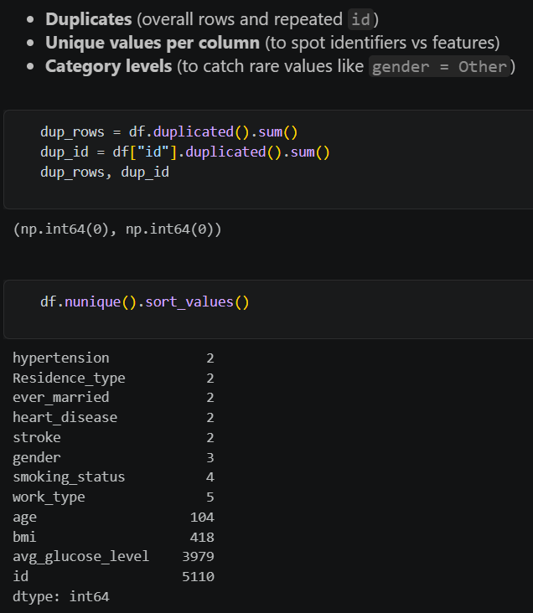

- Rare categories: gender = “Other” appears only once (out of 5,110 rows) and work_type = “Never_worked” appears only 22 times. Both are documented as low-count categories that need careful handling to avoid unstable one-hot columns.

Column | Category | Count
gender | Female | 2,994 (58.6%)
gender | Male | 2,115 (41.4%)
gender | Other | 1 (0.02%)
work_type | Private | 2,925 (57.2%)
work_type | Self-employed | 819 (16.0%)
work_type | children | 687 (13.4%)
work_type | Govt_job | 657 (12.9%)
work_type | Never_worked | 22 (0.4%)
smoking_status | never smoked | 1,892 (37.0%)
smoking_status | Unknown | 1,544 (30.2%)
smoking_status | formerly smoked | 885 (17.3%)
smoking_status | smokes | 789 (15.4%)

Check | Finding | Decision
Duplicate rows | No duplicate records reported in the EDA workflow | No de-duplication required
Identifier | id has no clinical predictive meaning | Dropped from feature matrix
Missing values | Only BMI has missing values: 201 rows | Median imputation plus bmi_missing flag
Rare gender category | gender = Other appears once | Avoid over-interpreting rare category behavior
Rare work category | Never_worked appears 22 times | Retain with caution in interpretation

Numeric Feature Summary
Statistic | Age | Avg glucose | BMI
mean | 43.23 | 106.15 | 28.89
std | 22.61 | 45.28 | 7.85
min | 0.08 | 55.12 | 10.3
25% | 25.0 | 77.24 | 23.5
50% | 45.0 | 91.88 | 28.1
max | 82.0 | 271.74 | 97.6

Target Class Distribution
The target variable is heavily imbalanced: only 249 of 5,110 patients (4.87%) experienced a stroke, while 4,861 (95.13%) did not. A model that simply predicts “no stroke” for every patient would already reach ~95% accuracy while being clinically useless — this is why the project prioritizes Recall, F1-score, ROC-AUC, and PR-AUC over accuracy throughout model selection.
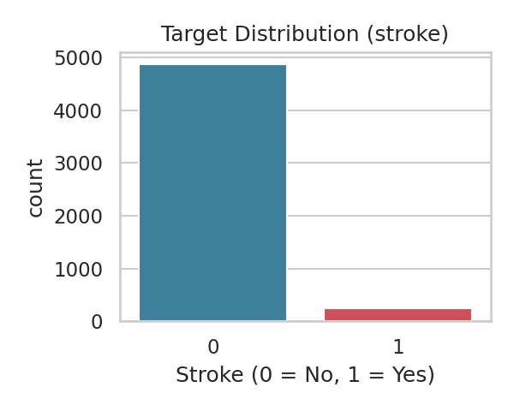
Figure 1. Target class distribution — stroke vs. no stroke.

Numeric Feature Distributions & Outliers
Three numeric features were examined in detail: age, avg_glucose_level, and bmi.
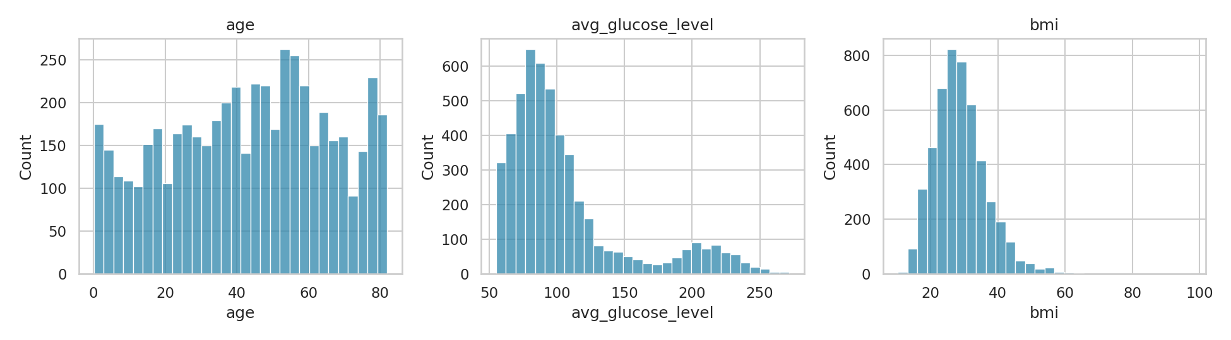
Figure 2. Distribution of age, average glucose level, and BMI.
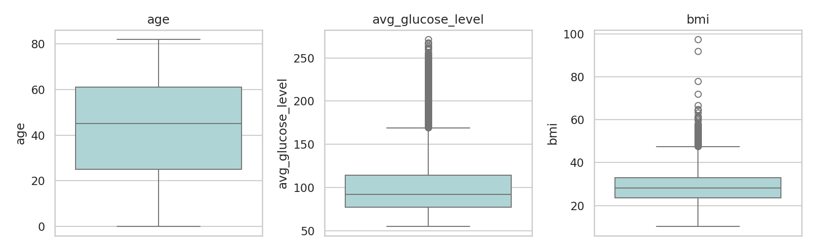
Figure 3. Boxplots highlighting spread and outliers in the numeric features.
- Age: roughly uniform across adult age ranges, which is favorable for a model that needs to distinguish risk across the full age spectrum.
- Average glucose level: right-skewed, with a cluster of patients showing elevated glucose (a known clinical risk marker).
- BMI: roughly bell-shaped but with missing values that are addressed later in this section.

An IQR-based outlier scan (1.5×IQR beyond Q1/Q3) quantifies how many values sit outside the typical range for the two continuous clinical variables:
Feature | Q1 | Q3 | IQR | Outliers (count) | Outliers (%)
avg_glucose_level | 77.25 | 114.09 | 36.85 | 627 | 12.27%
bmi | 23.50 | 33.10 | 9.60 | 110 | 2.24%

These outliers were not removed at this stage, since dropping them risks discarding rare but clinically meaningful stroke cases. Tree-based models are relatively robust to such outliers, and the option to apply capping/transformations remains open for future tuning.

Categorical Feature Distributions
Frequency counts for the five categorical predictors confirm reasonable coverage across most categories, with gender = “Other” and work_type = “Never_worked” standing out as rare levels (see table above) that warrant cautious interpretation.
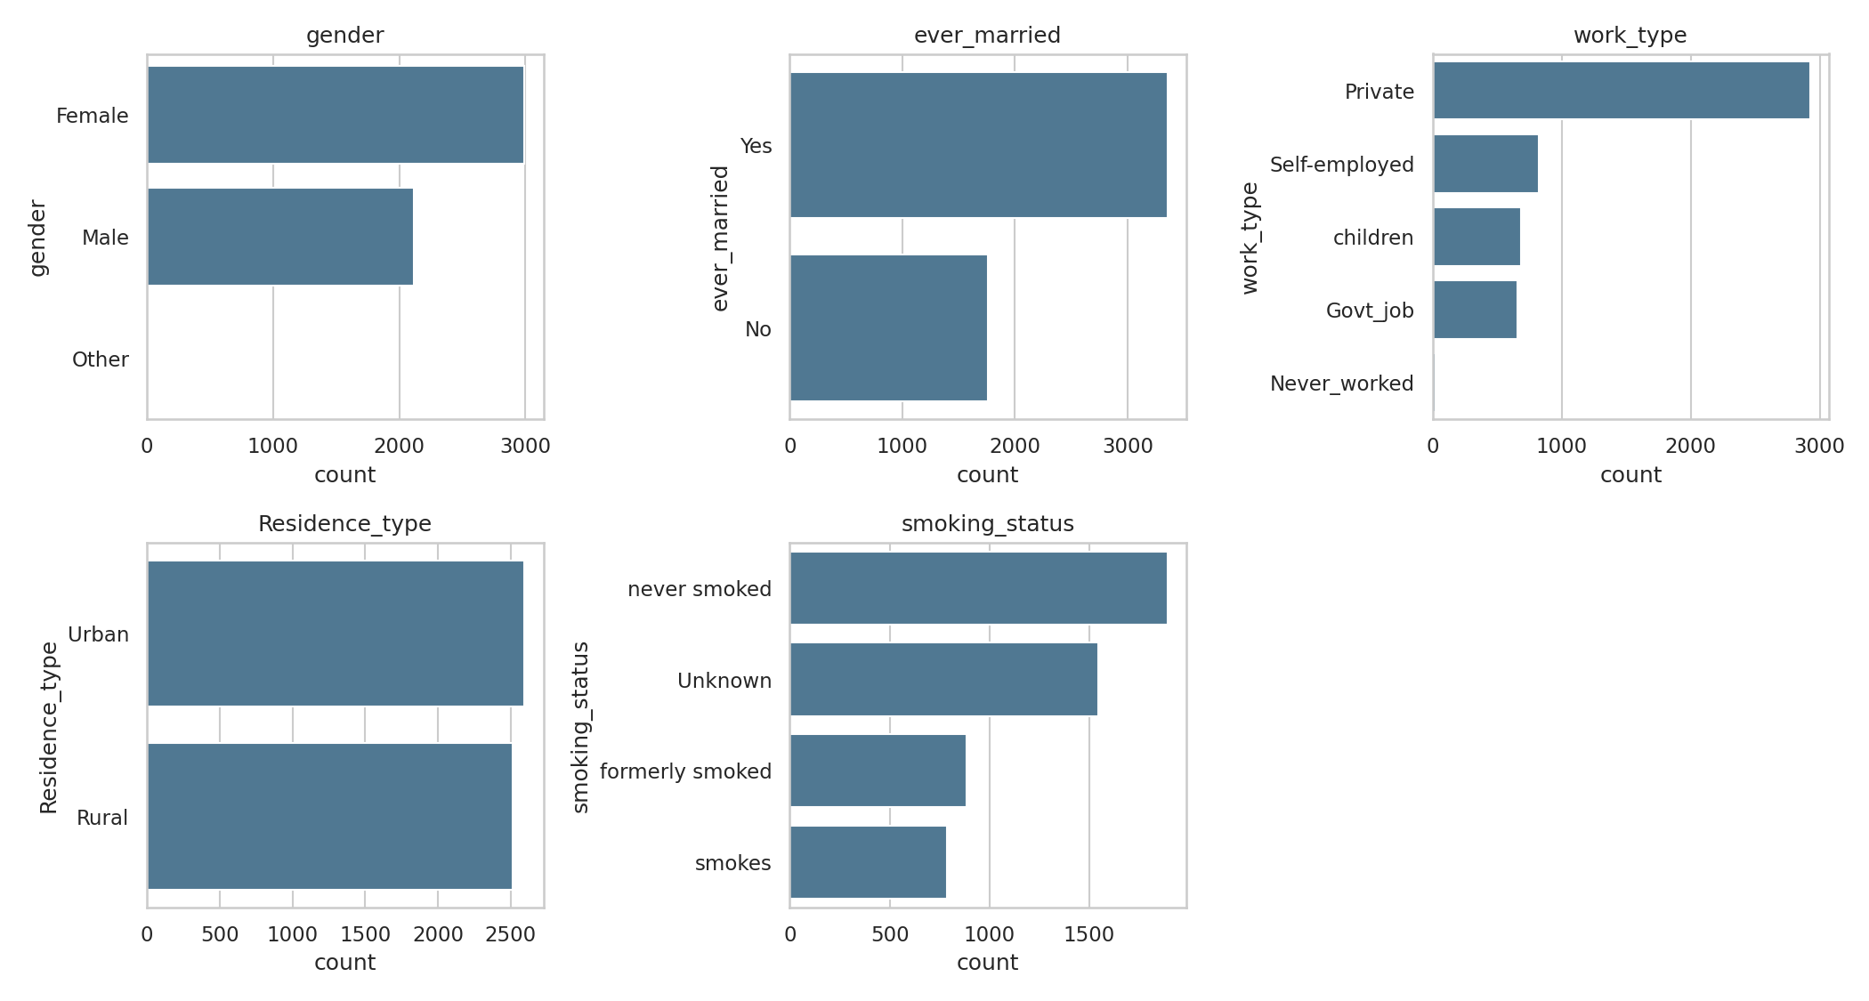
Figure 4. Category frequencies for gender, ever_married, work_type, Residence_type, and smoking_status.

Bivariate Analysis vs. Stroke
To identify which variables actually separate stroke from non-stroke patients, each feature is compared against the target.

Numeric features vs. stroke
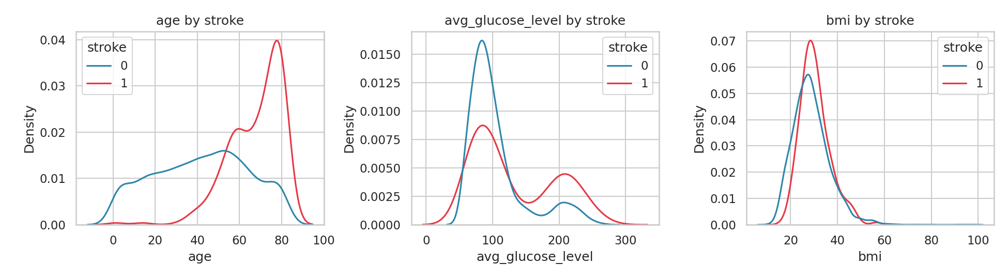
Figure 5. Density of age, glucose, and BMI split by stroke status.
The clearest separation appears in age: stroke cases skew markedly older. Average glucose level shows a secondary shift toward higher values among stroke patients, while BMI shows only a weak difference between the two groups — consistent with the near-zero correlation reported below.

Stroke rate by age group
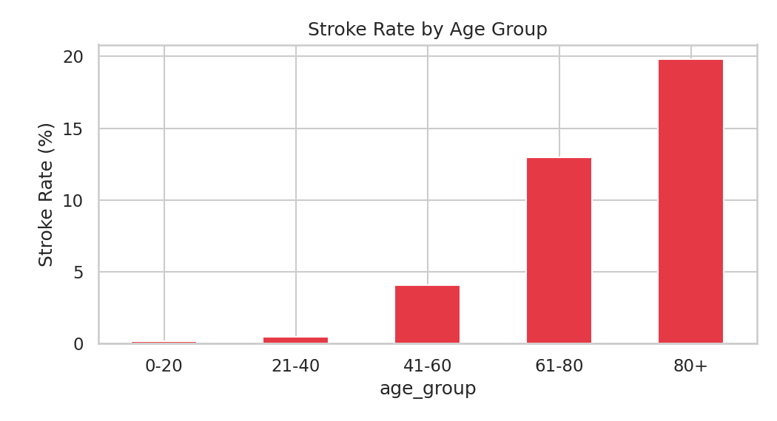
Figure 6. Stroke rate increases sharply with age.
Age Group | Stroke Rate
0–20 | 0.20%
21–40 | 0.49%
41–60 | 4.10%
61–80 | 12.96%
80+ | 19.83%

Stroke rate by hypertension and heart disease
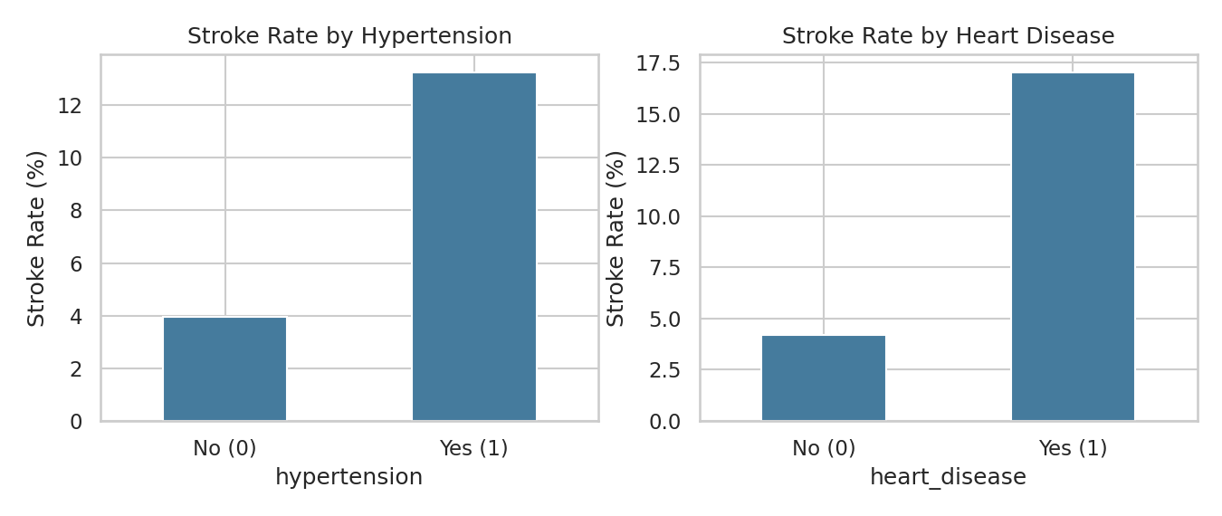
Figure 7. Both hypertension and heart disease roughly triple the observed stroke rate.
Patients with hypertension have a stroke rate of 13.25% versus 3.97% for those without — a more than 3x difference. Heart disease shows a similar pattern: 17.03% versus 4.18% for patients without heart disease.

Stroke rate by glucose group
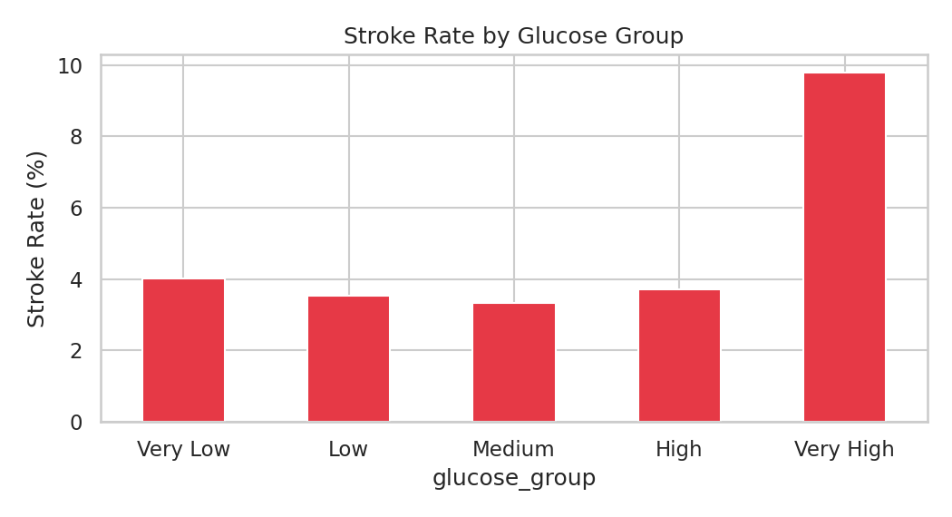
Figure 8. Stroke rate rises sharply in the top glucose quintile.
Splitting avg_glucose_level into quintiles shows a relatively flat stroke rate (3.3%–4.0%) for the bottom four groups, followed by a jump to 9.79% in the “Very High” glucose quintile — suggesting the relationship is concentrated at the high end of the glucose distribution rather than being linear throughout.

Stroke rate by category
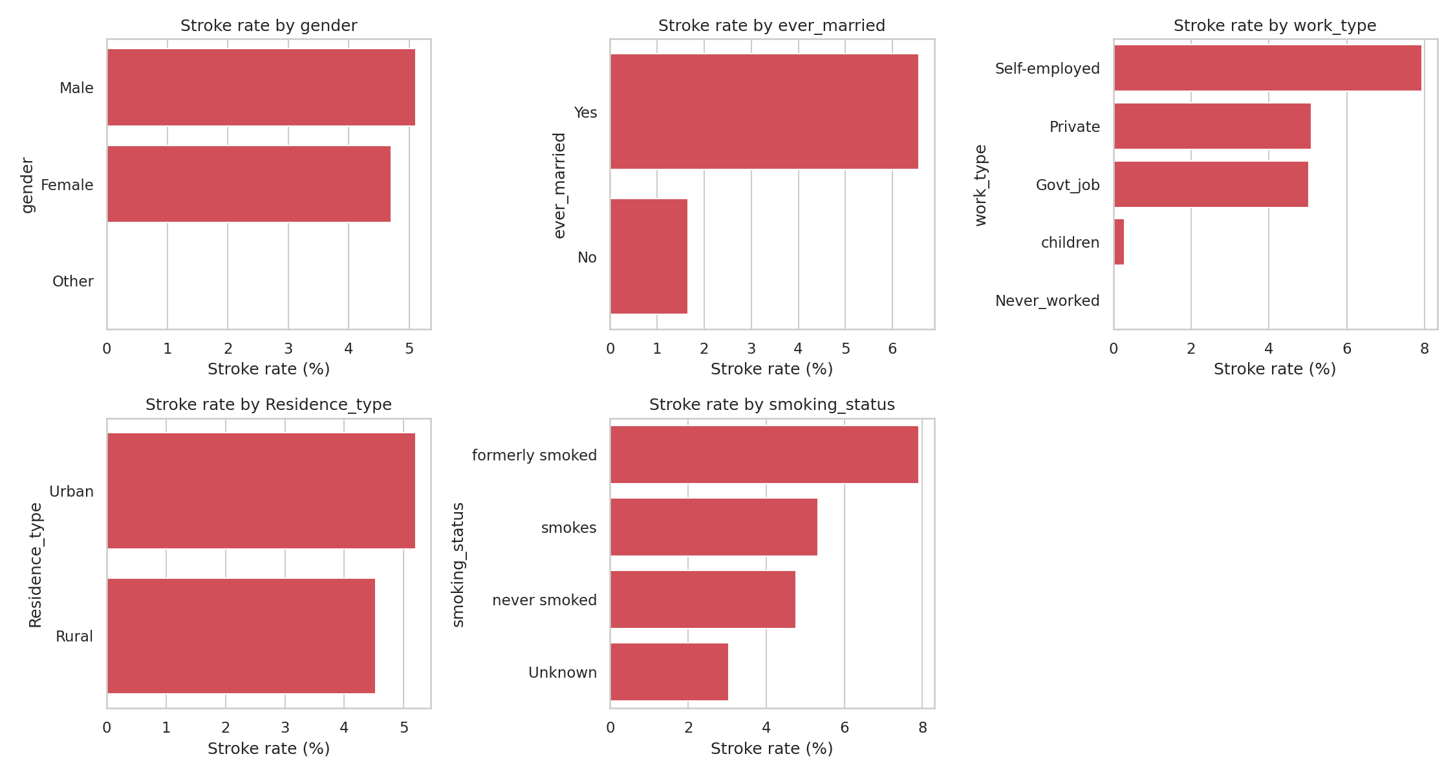
Figure 9. Observed stroke rate for each level of the categorical predictors (counts vary by category, so rare levels should be interpreted cautiously).
Self-employed individuals and formerly-smoked patients show the highest observed stroke rates among their respective categories, while children (work_type) show almost no stroke cases — unsurprising, since this category is dominated by very young patients. Because some categories (e.g. Never_worked) have very few observations, their rates carry wide uncertainty and are not treated as strong standalone signals.

Correlation Analysis
The project reports show that age has the strongest linear relationship with stroke among the numeric predictors, followed by heart disease, average glucose level and hypertension. BMI alone is weakly correlated, but BMI missingness is meaningful because missing BMI rows show a much higher observed stroke rate.
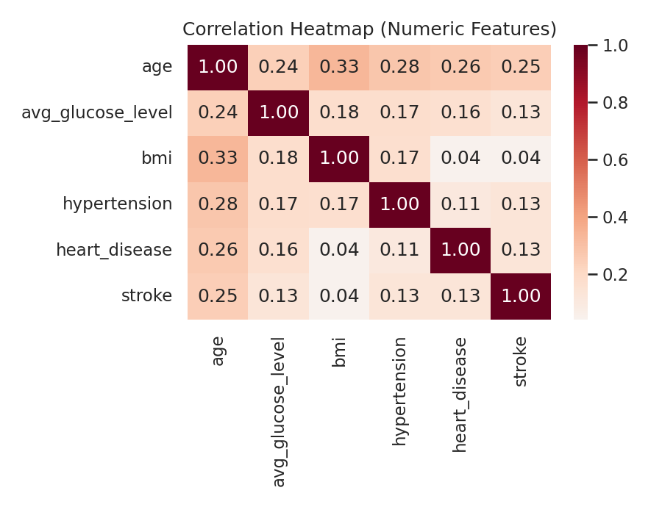
Figure 10. Correlation heatmap of numeric features and the target variable.
Age shows the strongest linear association with stroke (r = 0.245), followed by heart disease (r = 0.135), average glucose level (r = 0.132), and hypertension (r = 0.128). BMI is only weakly correlated with stroke (r = 0.042) despite being moderately correlated with age (r = 0.333) — a reminder that correlation captures only linear relationships and that the tree-based models later in the pipeline may still find non-linear BMI effects that this heatmap misses.

Missing Value Handling
Only bmi has missing values: 201 rows, or 3.93% of the dataset. Critically, missingness is not random — the stroke rate is 19.90% among patients with a missing BMI, versus 4.26% among patients with a recorded BMI. This roughly 4.7x gap indicates that missingness itself carries predictive signal, most likely because BMI was more often left unrecorded for patients who were more acutely ill or seen in different clinical contexts.
- Decision: rather than dropping rows (which would remove rare stroke cases) or imputing silently, the pipeline applies median imputation for bmi (robust to the outliers noted above) and adds a bmi_missing binary indicator so the model can still use the missingness signal directly.
- Rare category handling: the single gender = “Other” row is merged into an “Unknown” bucket to avoid an unstable one-hot column with a single observation.

Key EDA Findings
- The dataset is highly imbalanced: only about 4.9% of patients had a stroke.
- Age is the strongest visible risk-related feature; stroke rate increases clearly in older age groups.
- Hypertension and heart disease are associated with higher stroke rates.
- Average glucose level is right-skewed, and higher-glucose groups show higher stroke rates.
- BMI has 201 missing values, around 3.9% of the dataset.
- BMI missingness appears informative because rows with missing BMI have a higher stroke rate.
- Some categories are rare, such as gender = Other and Never_worked, so their stroke rates should not be over-interpreted.
- Because of class imbalance, modeling should use Recall, F1-score, ROC-AUC, and PR-AUC instead of accuracy alone.

Machine Learning Pipeline

Preprocessing Pipeline
The Milestone-1 cleaned output (5,110 rows) feeds a single scikit-learn ColumnTransformer that is fit only on the training split, so no information from the validation or test sets leaks into the fitted scaler or encoder.
- Numeric features (6): age, hypertension, heart_disease, avg_glucose_level, bmi, bmi_missing — standardized with StandardScaler.
- Categorical features (5): gender, ever_married, work_type, Residence_type, smoking_status — one-hot encoded, with unseen categories safely ignored at inference time.

Train / Validation / Test Split
Rather than a single train/test split, the team used a three-way stratified 60/20/20 split — training, validation, and test — so that the decision threshold could be tuned on the validation set and the test set could report a single, honest, previously-unseen estimate of performance.
Split | Purpose | Rows | Stroke = 0 | Stroke = 1
Train | Fit the preprocessing pipeline and each candidate model | 3066 | 2917 | 149
Validation | Compare all 6 candidate models and tune the decision threshold for the winner | 1022 | 972 | 50
Test | Report final, one-time performance of the selected model at its tuned threshold | 1022 | 972 | 50

Model Comparison (6 Candidates)
Six classifiers were trained inside identical preprocessing pipelines and compared on the validation set. Logistic Regression and Naive Bayes were run with class-balanced settings where supported; all models were evaluated primarily on ROC-AUC and PR-AUC, since accuracy is unreliable on a ~4.9%-positive dataset.
Model | Precision | F1 | Val. ROC-AUC | Val. PR-AUC | Val. Recall | Threshold*
Logistic Regression | 0.247 | 0.311 | 0.842 | 0.210 | 0.34 | 0.803
Random Forest | 0.200 | 0.302 | 0.829 | 0.206 | 0.52 | 0.373
Naive Bayes | 0.171 | 0.232 | 0.825 | 0.199 | 0.48 | 1.000
Support Vector Machine | 0.152 | 0.245 | 0.796 | 0.144 | 0.60 | 0.079
Decision Tree | 0.217 | 0.306 | 0.764 | 0.158 | 0.44 | 0.781
K-Nearest Neighbors | 0.149 | 0.190 | 0.746 | 0.181 | 0.38 | 0.148

*Threshold: the probability cut-off that maximized F1 for the positive class on the validation set for that specific model.

Best Model Selection & Threshold Tuning
Logistic Regression was selected as the final model: it leads on validation ROC-AUC (0.842) and PR-AUC (0.210), the two metrics the team prioritized for ranking quality on this imbalanced problem, and it remains a fully interpretable linear model — useful for a healthcare screening tool where some transparency into “why” a score is high matters. Its validation-tuned decision threshold of 0.8028 was then frozen and applied once to the untouched test set.
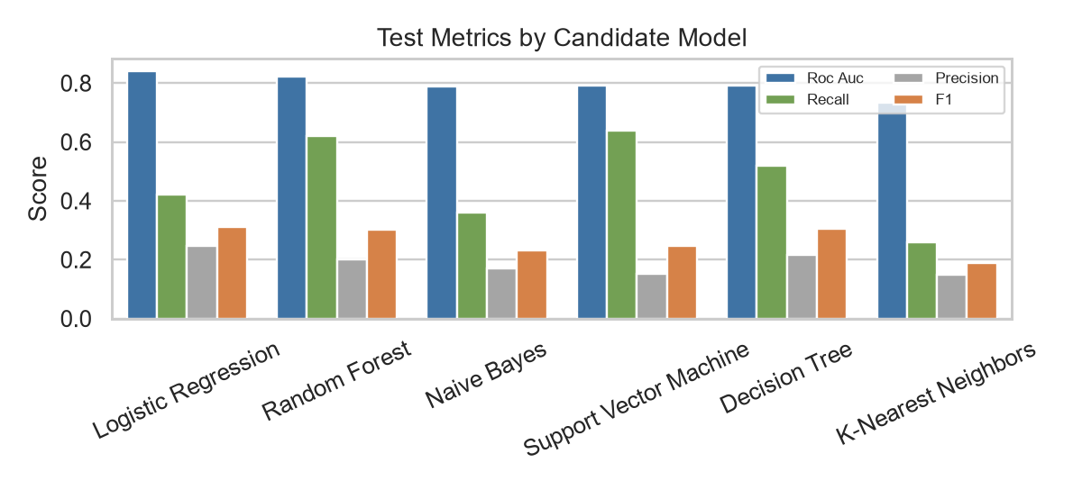
Figure 11. Candidate model test metrics from the project comparison CSV.

Evaluation Curves & Final Metrics
Confusion matrix, ROC curve, and precision-recall curve for the selected model on the held-out test set (1,022 patients, 50 with a stroke):
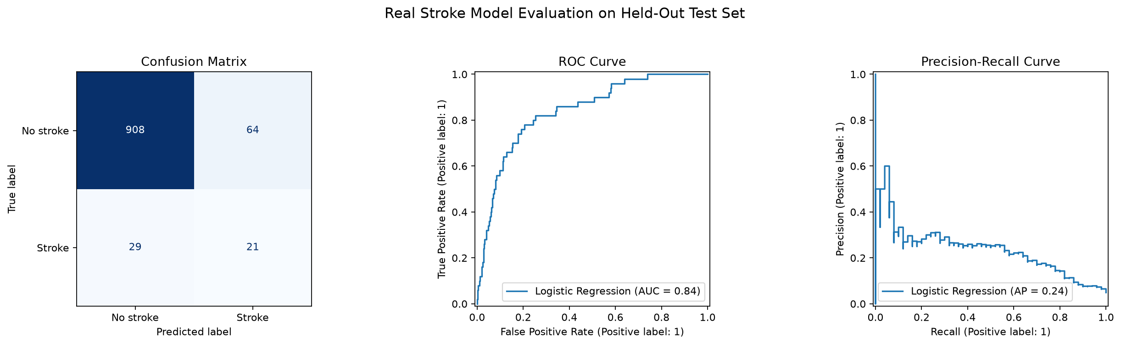
Figure 12. Confusion matrix, ROC curve, and precision-recall curve for Logistic Regression on the test set.
Metric | Value
Test Accuracy | 90.90%
Test Precision (stroke class) | 24.71%
Test Recall (stroke class) | 42.00%
Test F1 (stroke class) | 31.11%
Test ROC-AUC | 0.840
Test PR-AUC (Average Precision) | 0.238
Decision threshold | 0.8028
Out of 1,022 test patients, the model correctly flagged 21 of the 50 true stroke cases (recall 42%) while producing 64 false positives among the 972 non-stroke patients.
This reflects the fundamental precision/recall trade-off on a rare-event problem: catching more true positives requires accepting more false alarms, and the team chose the F1-optimal point on the validation set as a defensible, reproducible default rather than an arbitrary threshold.
Because missed strokes and unnecessary alerts carry very different real-world costs, the final operating threshold should ultimately be set jointly with clinical stakeholders.

Healthcare Context
For a healthcare screening tool, false negatives and false positives do not have equal cost. The current threshold was selected mathematically using validation F1, but a real clinical workflow should choose the operating threshold with domain stakeholders. A lower threshold may increase sensitivity, while a higher threshold may reduce alert burden.

MLOps, API & Deployment
Milestone 4 turns the trained pipeline into a runnable service. The team implemented two interfaces on top of the same StrokePredictor class — a REST API for programmatic access and a Streamlit app for interactive use — so both are guaranteed to produce identical predictions for identical input.

REST API (FastAPI)
The API (api/main.py) loads the serialized pipeline once at startup and exposes the following endpoints:
Endpoint | Method | Purpose
/health | GET | Reports service status and whether the model is loaded
/predict | POST | Scores a single patient record and returns probability, prediction, threshold, and risk level
/predict-batch | POST | Scores a list of patient records in one request

All request bodies are validated with Pydantic models before they reach the predictor — field types, numeric ranges (e.g., age between 0 and 120), and the exact category sets the model was trained on (e.g., gender must be ‘Female’ or ‘Male’) are enforced automatically, and violations return a structured HTTP 422 error rather than a silent failure or crash. This is verified directly in Section 7.

Streamlit Web Application
The Streamlit app (streamlit_app.py) presents the same fields as a two-column form, calls the shared predictor directly (in-process, no network hop), and renders the probability, the binary flag, and the active threshold. Full screenshots of the running app are shown in Section 8.

Monitoring & Retraining Strategy
The current deployment is local-only; the items below are the concrete Milestone 4 next steps the team identified for moving from a local demo to a monitored production service:
- Logging: extend the API to log every request's input feature summary, predicted probability, and threshold decision, enabling later audit and drift analysis.
- Drift detection: periodically compare the distribution of incoming requests (e.g., mean age, glucose) against the training distribution documented in Section 4, and alert if they diverge materially.
- Retraining trigger: re-run python -m src.train on an updated, labeled dataset on a fixed cadence or when drift is detected; the training script already regenerates the pipeline, metrics, and comparison report in one command, so retraining does not require code changes.
- Experiment tracking: MLflow is already listed as a project dependency; wiring the training script to log each run's parameters and metrics is the next step toward full experiment history.
- Cloud deployment: containerize the FastAPI service and deploy it behind a managed endpoint (e.g., a small cloud VM or container service) so the API is reachable outside the local host.

Testing & Quality Assurance

Test Plan & Functional Test Cases
Eight realistic patient profiles, spanning the risk spectrum and including an edge case with a missing BMI value, were submitted to the live /predict endpoint. Expected behavior was that risk should track age, hypertension, heart disease, and glucose level in the directions established during EDA, and that missing BMI should be handled gracefully rather than causing an error.
Test Case | Age | Result | Risk Level
Elderly, hypertension + heart disease, high glucose | 78 | 92.68% | High
Senior smoker, high glucose, BMI not recorded | 68 | 95.90% | High
Elderly, well-controlled (no hypertension/heart disease) | 81 | 72.70% | Medium
Middle-aged, obese, high glucose (diabetic profile) | 50 | 64.20% | Medium
Middle-aged, heart disease, normal glucose | 60 | 44.47% | Low*
Middle-aged, hypertension only | 55 | 39.63% | Low*
Young adult, no risk factors | 24 | 4.21% | Low
Child (work_type = children) | 9 | 3.91% | Low

*“Low” here means below the 0.803 high-risk threshold, not clinically negligible — see the discussion below.

All eight cases passed: the ranking of probabilities matched clinical expectation (age and comorbidities push risk up; a healthy young patient and a child score lowest), and the BMI-missing case was processed without error, confirming the bmi_missing indicator path works correctly in the deployed pipeline, not just in the training notebook.
Test observation worth flagging
The 81-year-old with no hypertension, no heart disease, and normal glucose still scored 72.70% — below the high-risk threshold, but far from negligible. This is expected given age's outsized coefficient and is a useful, honest finding for the Limitations section: the model leans heavily on age, so very elderly patients score elevated risk almost regardless of other factors.

Input Validation Tests
Three deliberately invalid requests were sent to confirm the API fails safely rather than silently:
Invalid Input | HTTP Status | Result
gender = “Other” (outside the trained categories) | 422 | Rejected — “Input should be 'Female' or 'Male'”
age = 200 (exceeds allowed range) | 422 | Rejected — “Input should be less than or equal to 120”
Missing required field (Residence_type omitted) | 422 | Rejected — “Field required”

The batch endpoint (/predict-batch) was also tested with a two-record request (one high-risk, one low-risk profile) and returned both predictions correctly in a single response, confirming the batch-scoring functional requirement from Section 2 is met.

Application Walkthrough
The screenshots below were captured from the actual running Streamlit application (streamlit_app.py), backed by the live FastAPI service described before, using the same two test cases highlighted before.
They demonstrate the full path from user input to a displayed risk result, not a mockup.

Step 1 — Empty Form
The application loads with sensible defaults (a 45-year-old with no major risk factors) so the form is never blank or confusing on first load.
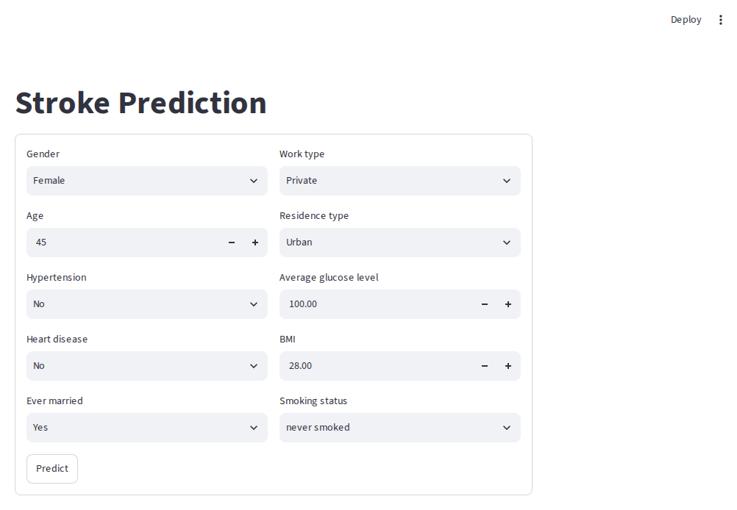
Figure 13. Stroke Prediction app on first load, before any changes.

Step 2 — High-Risk Patient
An elderly patient profile with hypertension, heart disease, and a high average glucose level (age 78, hypertension = Yes, heart disease = Yes, glucose = 210.5, BMI = 32.1, formerly smoked) was entered and submitted.
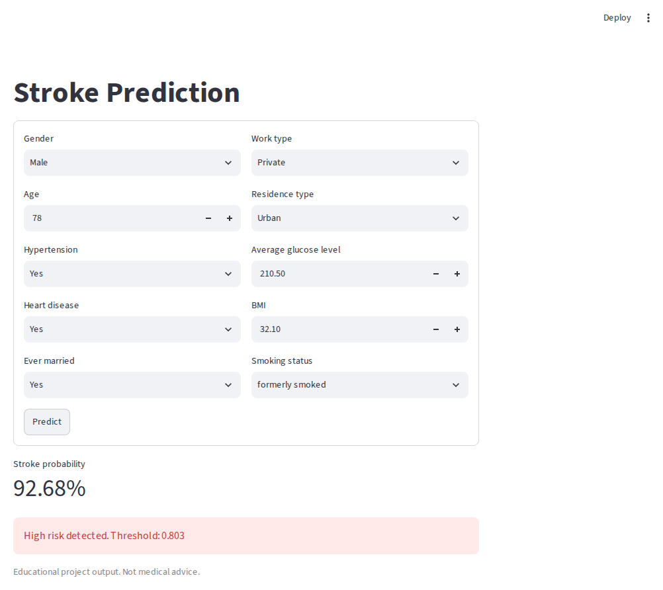
Figure 14. Result for the high-risk profile — 92.68% stroke probability, flagged as high risk against the 0.803 threshold.

Step 3 — Low-Risk Patient
A healthy young adult profile (age 24, no hypertension, no heart disease, normal glucose and BMI, never smoked) was entered next, using the same running app instance.
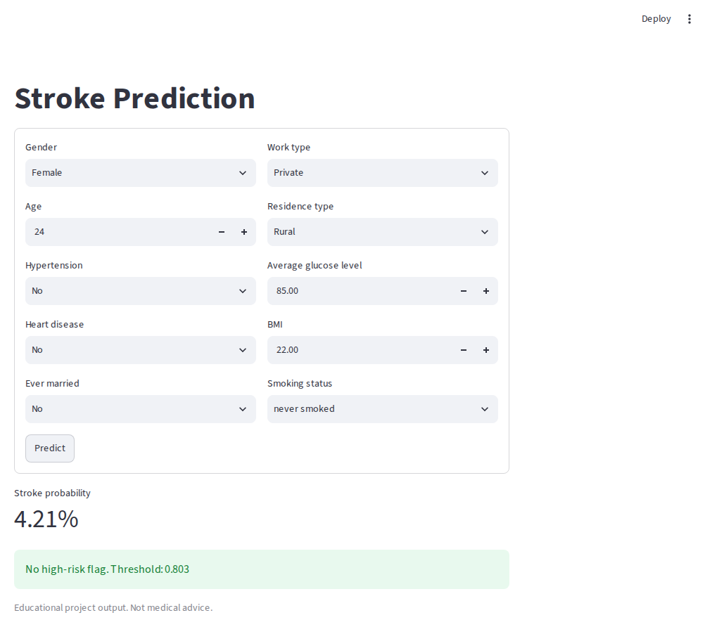
Figure 15. Result for the low-risk profile — 4.21% stroke probability, no high-risk flag.
Both results match the direct API responses recorded in Section 7 exactly (92.68% and 4.21% respectively), confirming the Streamlit UI and the FastAPI service are consistent with each other because they share the same underlying StrokePredictor and model artifact.

Model Summary & Current Performance
The deployed model is a Logistic Regression classifier trained inside a leak-free preprocessing pipeline, selected over five other candidates (Random Forest, Decision Tree, K-Nearest Neighbors, Support Vector Machine, and Naive Bayes) because it achieved the best validation ROC-AUC and PR-AUC — the metrics the team prioritized for a severely imbalanced target.

Input Features
- Demographics: gender, age, ever_married, Residence_type
- Clinical indicators: hypertension, heart_disease, avg_glucose_level, bmi, bmi_missing
- Lifestyle factors: work_type, smoking_status

Current Performance Snapshot
Metric | Validation | Test
ROC-AUC | 0.842 | 0.840
PR-AUC (Average Precision) | 0.210 | 0.238
Recall (stroke class) | 0.34 | 0.42
Precision (stroke class) | — | 0.247
F1 (stroke class) | 0.288 | 0.311
Accuracy | 0.918 | 0.909

The consistency between validation and test ROC-AUC (0.842 vs. 0.840) indicates the model is not overfit to the validation split used for threshold tuning — a direct benefit of the three-way split design described before.

Limitations & Future Work
This report reflects a complete pass through all five milestones, including a working local deployment and a real functional test pass. The following items are the concrete next steps the team identified from the current results, consistent with the risks flagged :
- Modest precision at the tuned threshold: 24.7% test precision means roughly three out of four flagged patients will not go on to have a stroke; the threshold trades this against catching 42% of true stroke cases, and the operating point should ultimately be set with clinical input rather than by F1 alone.
- Age dominates the score: as observed directly in testing section, elderly patients score elevated risk even without other risk factors present, which is expected from a linear model but should be communicated clearly to any end user of the tool.
- Small positive class: only 249 stroke cases in the entire dataset limits how confidently the team can generalize test-set metrics; more labeled data would tighten these estimates.
- No resampling explored yet: techniques such as SMOTE were considered in scope during planning but not yet applied; comparing them against the current class-weighting approach is a natural next experiment.
- Tree-based models underperformed: Random Forest, Decision Tree, and KNN all trailed Logistic Regression on ROC-AUC/PR-AUC in this comparison; targeted hyperparameter tuning (grid or randomized search) was not yet applied to any candidate and may close this gap.
- Deployment is local-only: cloud hosting, authentication, and the monitoring/retraining automation described remain to be implemented for a production-grade Milestone 4.
- No persistent request logging yet: the API does not currently store submitted requests or predictions, which would be needed for the drift-detection strategy in Section 6.

Conclusion
The Healthcare Predictive Analytics Project delivers a complete, working pipeline for stroke risk prediction: a cleaned and thoroughly explored dataset, a rigorous six-model comparison with an imbalance-aware evaluation methodology, a validation-tuned decision threshold, and a deployed system — both a REST API and a Streamlit web application — that was directly tested with a structured set of functional test cases rather than left as an offline exercise.
The selected Logistic Regression model achieves a test ROC-AUC of 0.840 and correctly identifies 42% of true stroke cases at its tuned threshold, with the trade-offs and limitations of that operating point documented transparently in this report. Every one of the five DEPI Round 4 milestones for this project — data collection, advanced analysis, model development, deployment, and final documentation — has a corresponding, verifiable artifact in the submitted repository, and every team member's contribution is traceable to a specific milestone and section of this report.
Although the developed model achieved promising predictive performance, it is important to recognize that machine learning models are designed to assist—not replace—medical professionals. The predictions generated by the system should be considered an additional source of information to support clinical decision-making. Patients should always seek evaluation and diagnosis from qualified healthcare providers, as medical decisions require comprehensive clinical assessment beyond the variables included in the dataset. Therefore, this system should be used only as a decision-support tool and must not be relied upon as the sole basis for medical diagnosis or treatment decisions

Appendix — Repository Structure
For reference, the submitted project archive is organized as follows:
Path | Contents
api/main.py | FastAPI application — /health, /predict, /predict-batch
src/train.py | End-to-end training script: loads data, builds the pipeline, compares 6 models, tunes the threshold, saves the artifact and reports
src/predict.py | StrokePredictor class shared by the API and the Streamlit app
streamlit_app.py | Web application entry point
Notebooks/EDA_Notebook.ipynb | Executed exploratory data analysis (Milestones 1–2)
Notebooks/Modeling_Notebook.ipynb | Executed model comparison notebook (Milestone 3)
dataset/ | Raw and processed CSV data, including the unused alternate source kept for traceability
models/stroke_model_pipeline.joblib | Serialized preprocessing + model pipeline and tuned threshold
reports/ | Model comparison CSVs, audit CSV, split summary, evaluation figures, and the model report text file
requirements.txt | Python dependencies for reproducing the environment
README.md | Project overview and run instructions
To reproduce the results in this report: install requirements.txt, run python -m src.train to regenerate the model and reports from raw data, then launch uvicorn api.main:app and streamlit run streamlit_app.py to bring up the API and web app respectively

